**DAILY ONLINE ACTIVITIES SUMMARY**

|  |  |  |  |  |  |  |  |  |
| --- | --- | --- | --- | --- | --- | --- | --- | --- |
| **Date:** | **02/06/2020** | | | | | **Name:** | **Prashant Rama Bhat Kodlekere** | |
| **Sem & Sec** | **4th sem (B sec)** | | | | | **USN:** | **4AL18CS060** | |
| **Online Test Summary** | | | | | | | | |
| **Subject** | | **Not conducted** | | | | | | |
| **Max. Marks** | | **-** | | **Score** | | | **-** | |
| **Certification Course Summary** | | | | | | | | |
| **Course** | **Step into robotic process automation** | | | | | | | |
| **Certificate Provider** | | | **GUVI(in association with Ui Path)** | | **Duration** | | | 3 hours |
| **Coding Challenges** | | | | | | | | |
| **Problem Statement:** Given an array of positive integers. Write a C Program to find inversion count of array  Top of Form  Bottom of Form | | | | | | | | |
| **Status:Completed** | | | | | | | | |
| **Uploaded the report in Github** | | | | | **YES** | | | |
| **If yes Repository name** | | | | | **https://github.com/prashantkodlekere/codingactivity** | | | |
| **Uploaded the report in slack** | | | | | **YES** | | | |

Certification Course Details:

Course name: **Step into robotic process automation**

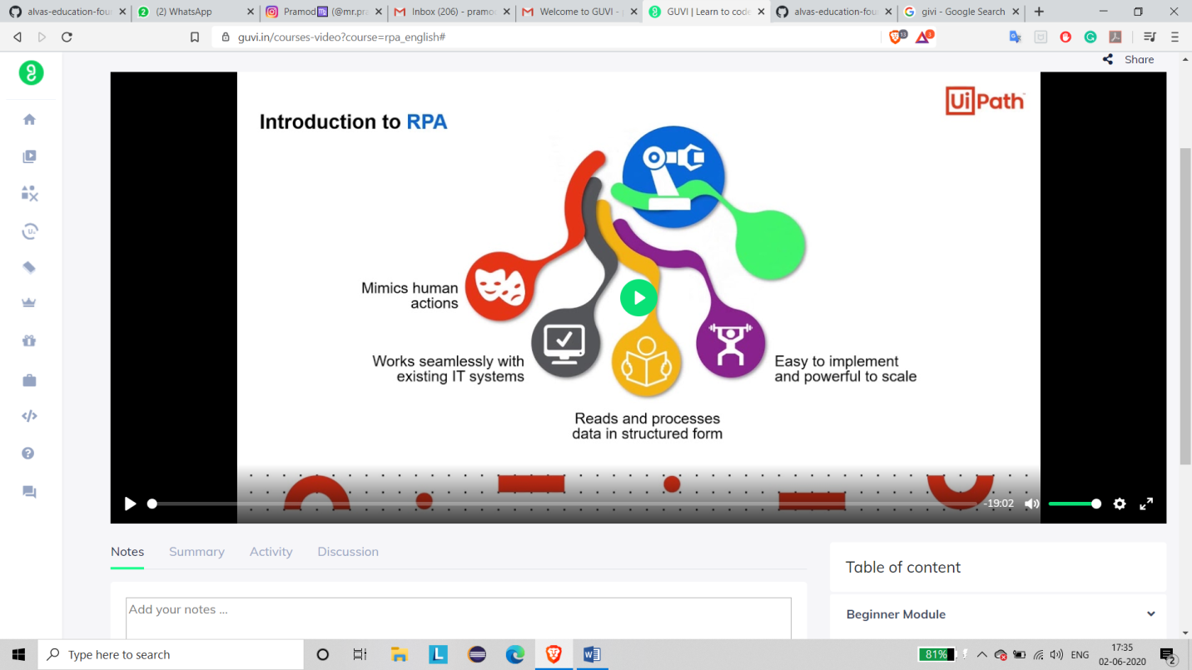

The course I have completed today is Step into Robotic Process

Automation. Robotic Automation is one of the trending technologies in the

IT sector. It has a bright future in the IT sector. Since Robotic Automation

can change the trend in the IT sector I have done this course today.

Coding Challenges Details:

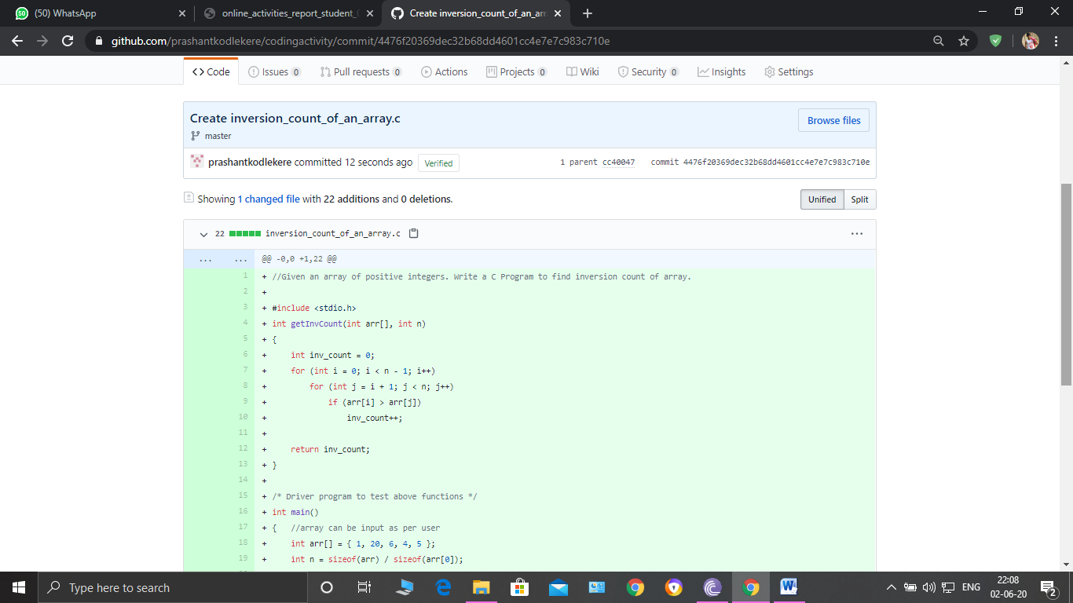

**The question I took to code is:**

Given an array of positive integers. Write a C Program to find inversion count of array.

Code: The above snapshot is the code which I have uploaded in my Github repository.